Step 1: Go to chrome -search for spring initializr
Step 2 : project – maven
Language – java
Spring boot version :4.1.1
Project meta data
Group – com.example
Artifact -springsec
Package name -com.example.springsec
Step 4 : Adding dependencies
- Spring security
- Spring web
- Spring dev tools
- Mysql driver

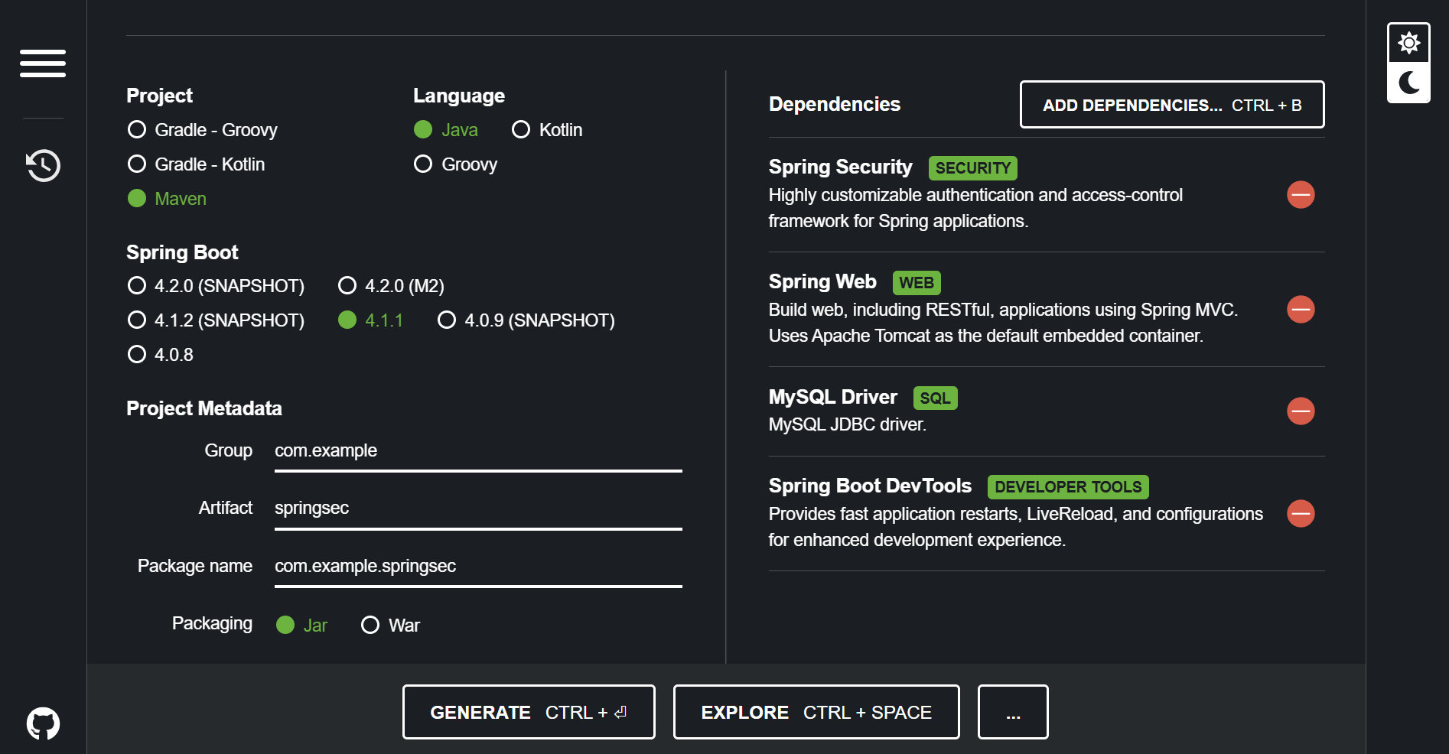
Click on generate – extract downloaded files
Step 5 : open dependencies file In IntelliJ idea
Step 6 : open the source – java file
Demoapplication.java
package com.example.demo;
import org.springframework.boot.SpringApplication;
import org.springframework.boot.autoconfigure.SpringBootApplication;
@SpringBootApplication
public class DemoApplication {
public static void main(String[] args) {
SpringApplication.run(DemoApplication.class, args);
}
}
Step 7 : create another class within the same source file
package com.example.demo;
import org.springframework.web.bind.annotation.GetMapping;
import org.springframework.web.bind.annotation.RestController;
@RestController
public class Hellocontroller {
@GetMapping("/")
public String greet(){
return("welcome !");
}
}

Focus to create the Annotations of RestController & Getmapping 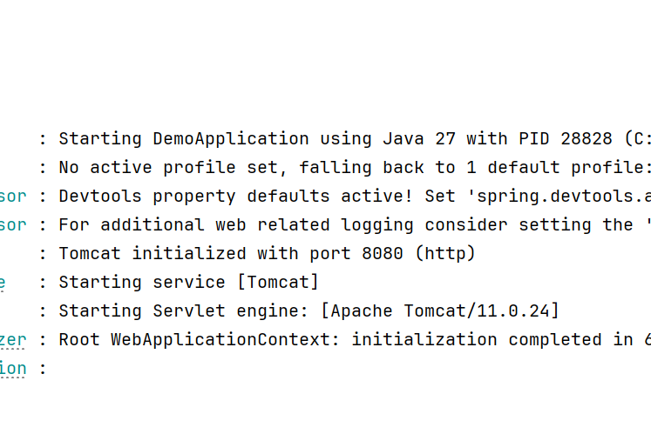
Check for the port no given and run in chrome : localhost 8080
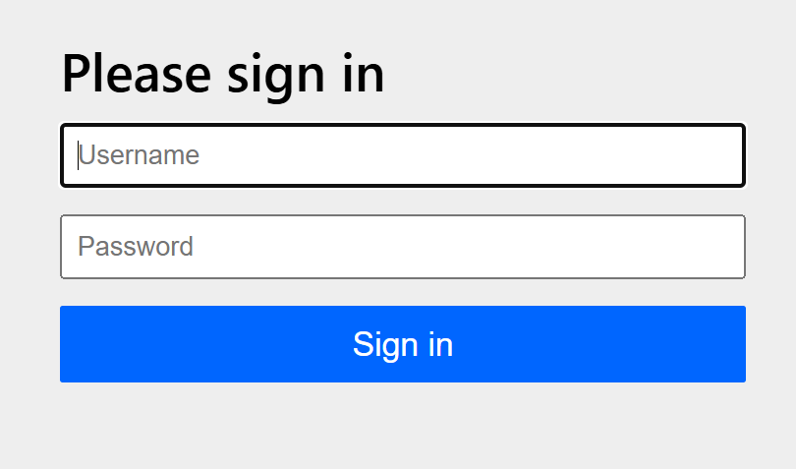
Now on sign in page – sigin in by submitting user name as user & password as generated by spring boot `
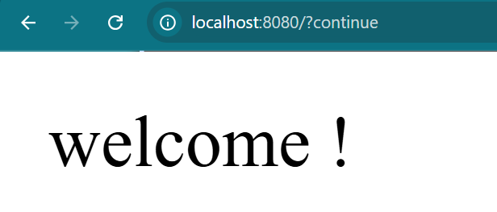
Spring Security is a powerful and highly customizable authentication and access-control framework. It is the de-facto standard for securing Spring-based applications.
Spring Security is a framework that focuses on providing both authentication and authorization to Java applications. Like all Spring projects, the real power of Spring Security is found in how easily it can be extended to meet custom requirements
Features
- Comprehensive and extensible support for both Authentication and Authorization
- Protection against attacks like session fixation, clickjacking, cross site request forgery, etc
- Servlet API integration
- Optional integration with Spring Web MVC

